Day 14 - tdyeswan - 2nd July 2025

Task 1:

Create a custom node , add elements to it and traverse it..

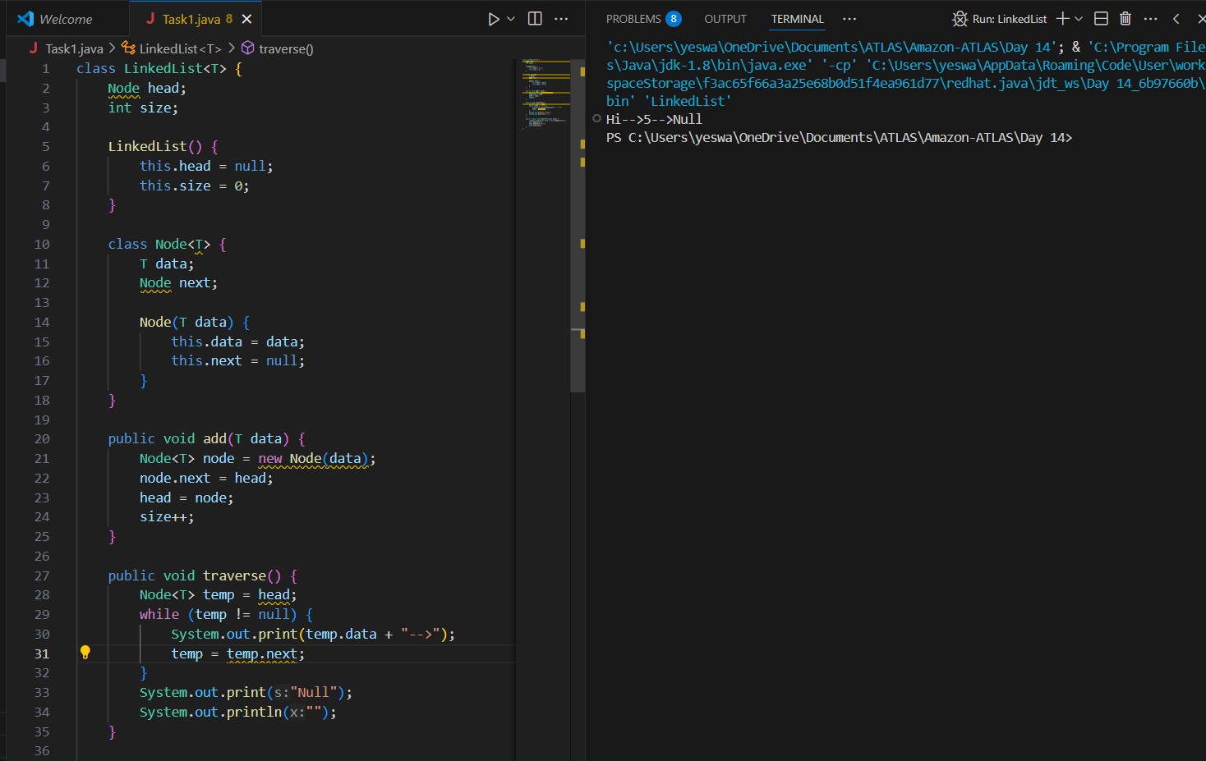

Task 2:

What do you understand by traversing elements in a linked list.
Traversing elements means gliding through the linked list using temp/any dummy variable.

Task 3:

Create a Circular Linked list using Task 1 Singly linked list.

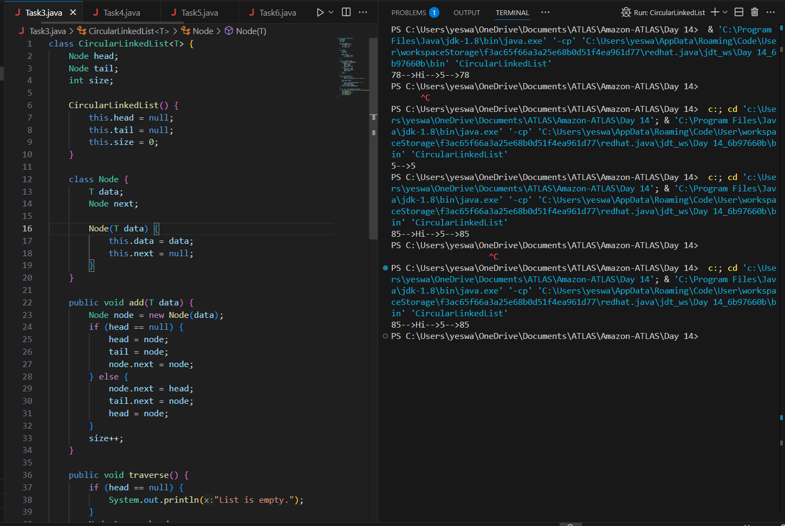

Task 4:

Stacks

Create a code to implement a stack

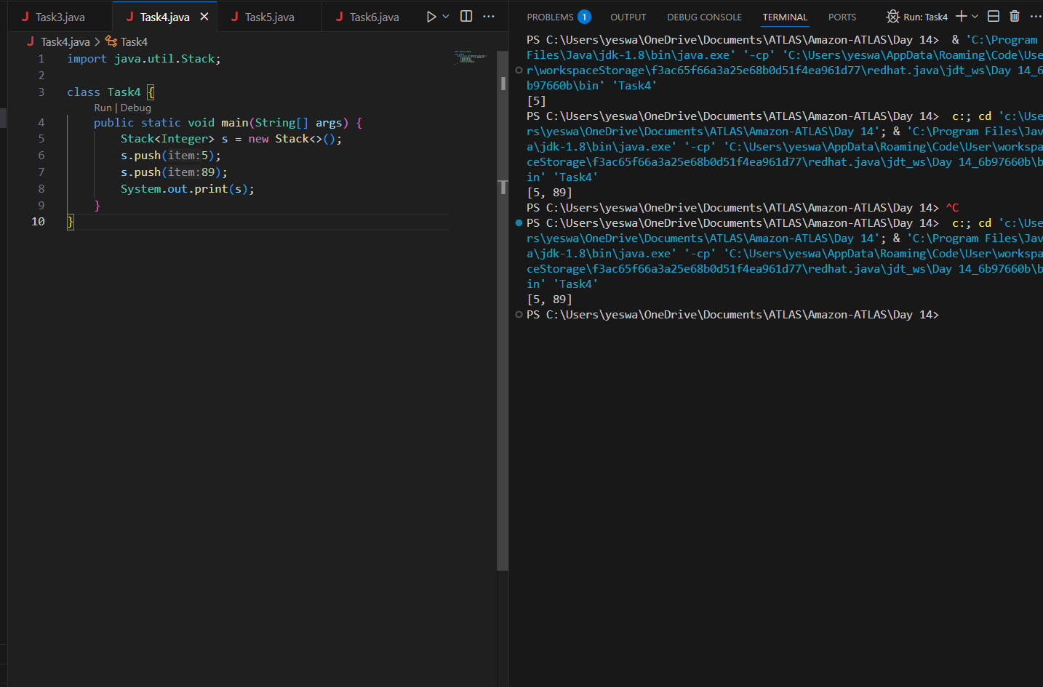

Task 5:

Create a stack and pop the element also print the popped element.

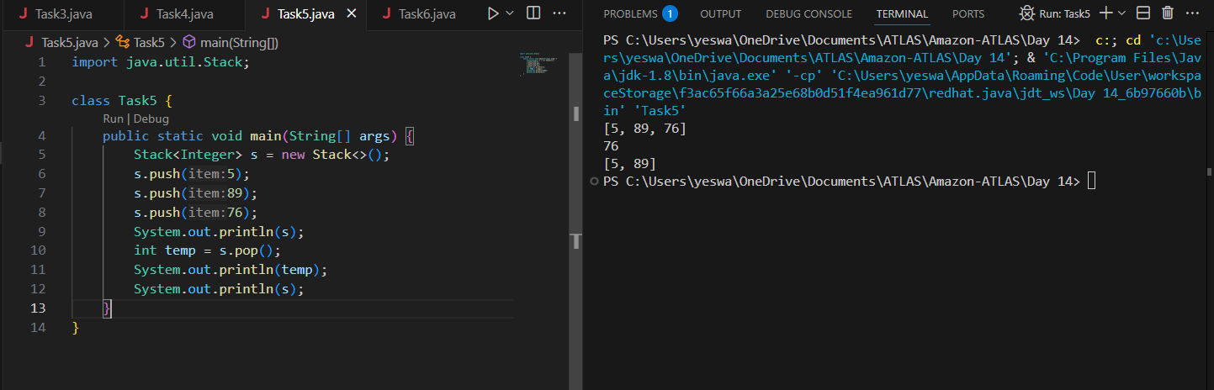

Task 6:

Find an element in the stack and display the position

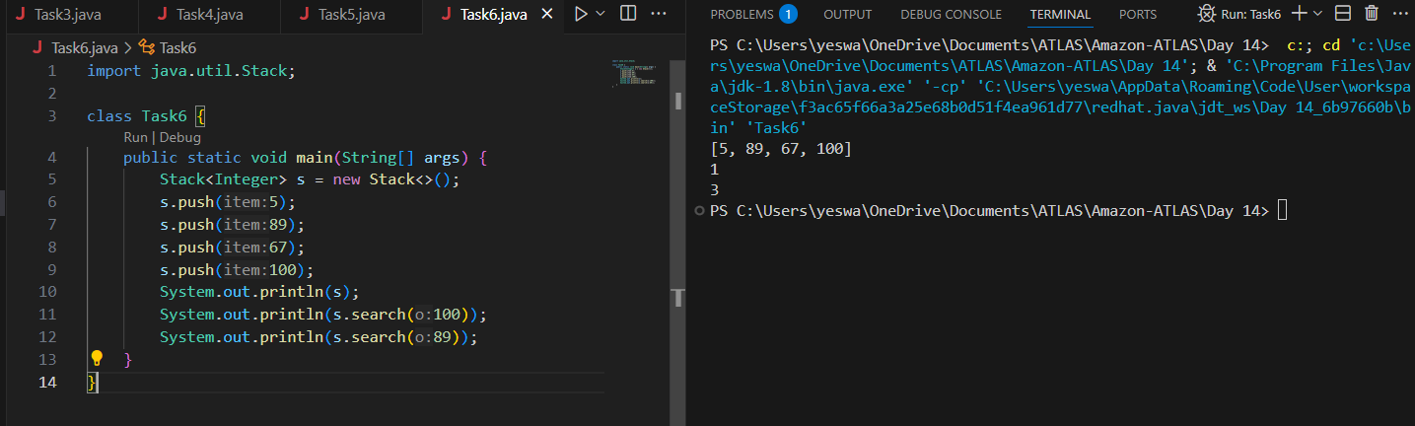

Task 7:

Peek the element and print it ..

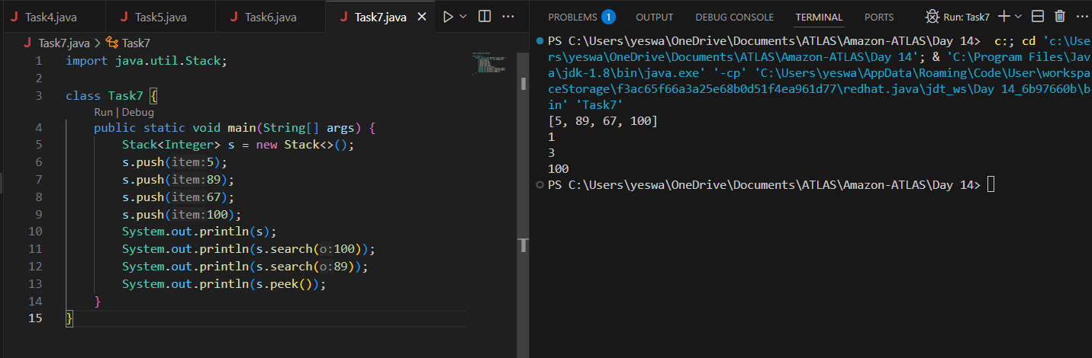

Task 8:

Check if the stack is empty or not?

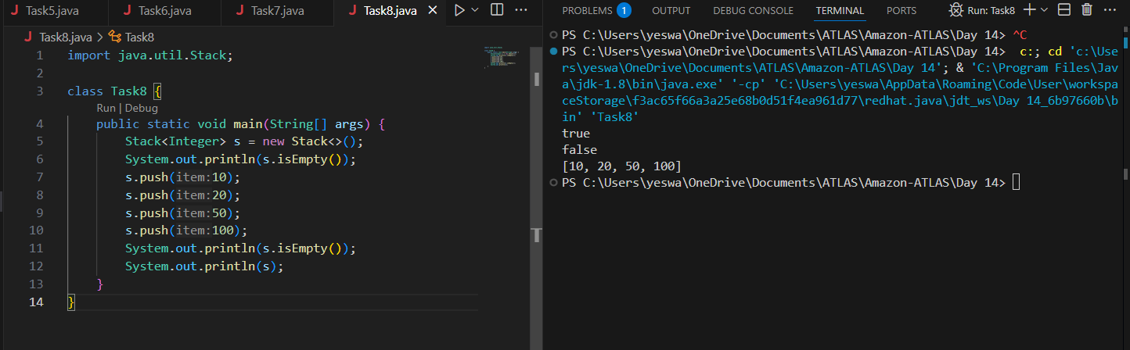

Task 9:

What are the methods of the stack class?

- push()
- pop()
- peek()
- empty/isempty()
- search()

Task 10:

What are the common operations in queue?

- enqueue(Add)
- Dequeue
- Peek
- Size
- Empty
- Checksize
- Clearall.

Task 11:

Wap to create a queue with custom methods
Is empty ()
Is full()
Enque
Deque
Peek
display()

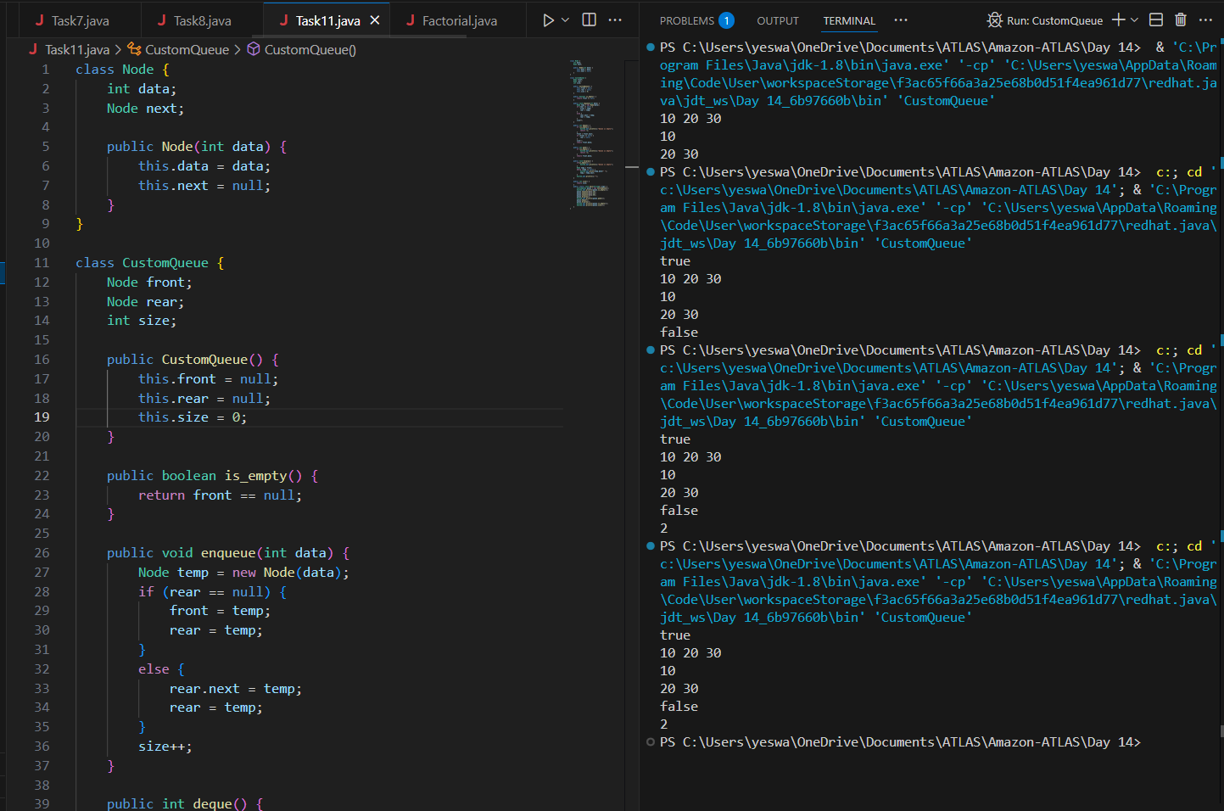

HOME TASKS
1. Wap to find the factorial of a number

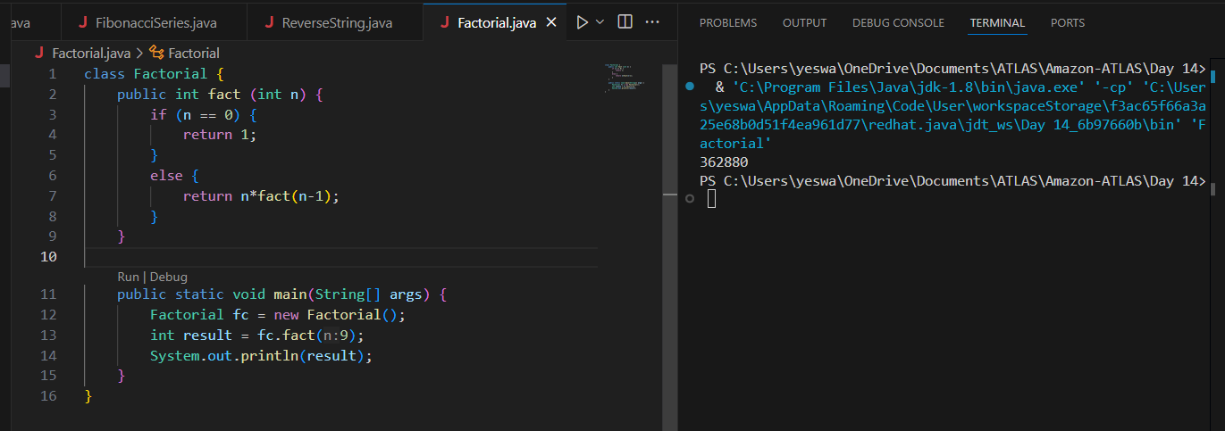

2. Wap to find the Fibonacci series of a number

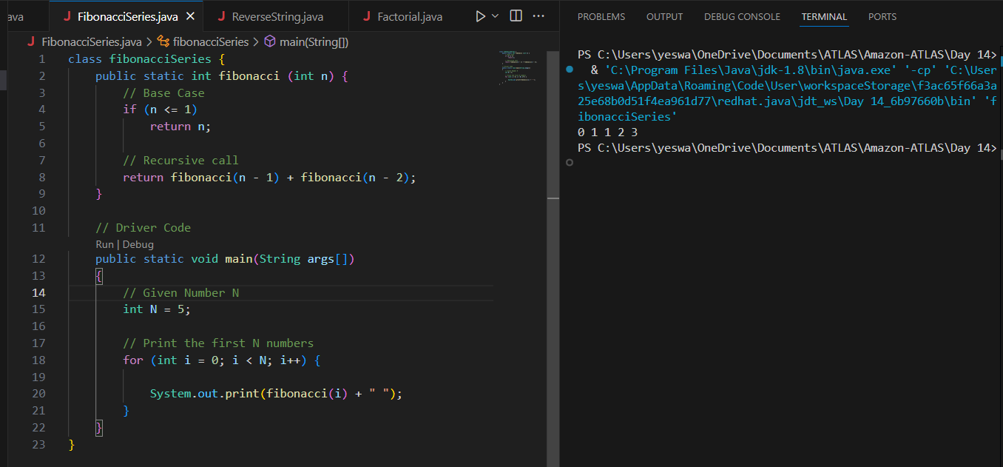

3. What is the difference between recursion and iteration

Property | Recursion | Iteration
Definition | Function calls itself. | A set of instructions repeatedly executed.
Application | Certain problems can be solved quite easily using recursion like Towers of Hanoi (TOH), Inorder/Preorder/Postorder Tree Traversals, DFS of Graph, etc. | In general iterative solutions are preferred over recursive solutions as there is no extra overhead required for recursion.
Termination | Through base case, where there will be no function call. | When the termination condition for the iterator ceases to be satisfied.
Usage | Used in academics to teach foundations and logic. Also works as a foundation for Dynamic Programming and Divide and Conquer algorithms. | Preferred in general.
Code Size | Can be smaller code size for inherently recursive problems. | Can be larger for naturally recursive problems.
Time Complexity | In general time complexity is higher or same. The time complexity especially become higher for the problems that can be optimized using dynamic programming | Lower or same.
Space Complexity | In general, the auxiliary space is either higher. Can be same in same cases where we need an explicit stack to simulate recursion like tree traversals, merge sort, etc. | Generally lower
Overhead | Possesses overhead of repeated function calls. | No overhead as there are no function calls in iteration.

4. Wap to reverse a string using recursion..

